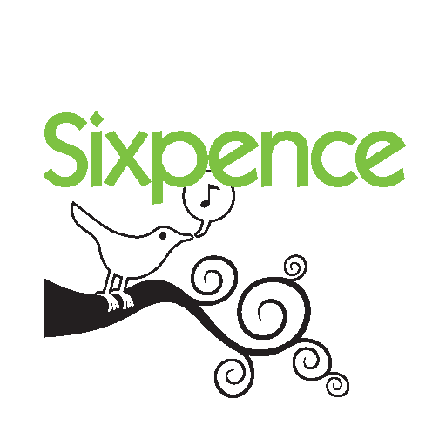

NEBRASKA EARLY CHILDHOOD EDUCATION ENDOWMENT
BOARD OF TRUSTEES
AGENDA
Wednesday, May 31, 2017
1:00-4:00 CST
Nebraska Children and Families Foundation
- Centennial Mall South, Suite 200, Lincoln, NE

- Welcome & Introductions; Open Meetings Act information Roll Call

- Guests Fabiola Dimas and Daisy Ortiz from Crete share their experience on Capitol Hill through Zero to Three’s Strolling Thunder event Discussion*

- Approve Minutes from March 15, 2017 (Support Material) ACTION

- Review Financial Reports; discuss anticipated CCDF funds
(Support Materials; Shane Rhian & Kevin Cloonan attending) Discussion*

- Discuss North Platte’s letter declining CCP grant award (Support Material) Discussion*

- Review All Grantees Status Report (Support Material) Discussion*

- Review and approve continuation funding requests from all current grantees
(Support Materials) ACTION

- Approve evaluation budget, designating Board Chair to sign contract with UNMC-MMI (Support Materials) ACTION

- Approve Falls City’s carryover request (Support Material) ACTION

- Discuss the role of Sixpence Administrator with Nebraska Children’s work in early childhood community capacity building and the impact on the TA costs (Support Material) Discussion*

- Adjourn ACTION

*After each discussion item, there will be opportunity for public input.

Next Meeting: Wednesday, September 20, 2017 1:00-4:00pm
Agenda items: approve TA budget, evaluation report

