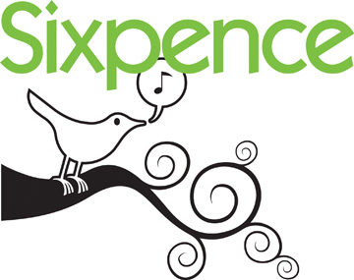
Grant Guidance

Program Assistance Document

Nebraska’s Early Childhood Education Endowment Grant Program

Early Childhood Education Programs and Services for Children Birth to Age Three at Risk of School Failure and Their Families

Nebraska Children and Families Foundation, 215 Centennial Mall South Suite 200, Lincoln, NE 68508 • 402.476.9401 • www.nebraskachildren.org

TABLE OF CONTENTS
History of Sixpence…………………………………………………………………………………………..3
Types of Sixpence Grants………………………………………………………………………………….4
Purpose - Targeted Population………………………………………………………………………….5
Enrolling Children……………………………………………………………………………………………..6
NSSRS and Attendance……………………………………………………………………………………..7
Staff Qualifications……………………………………………………………………………………….....9
Sixpence Bilingual Education Policy………………………………………………………………….10
Intensity and Duration of Services………………………………………………………..............12
Sixpence Transition Policy………………………………………………………………………………..14
Supervision………………………………………………………………………………………………………15
Caseload, Curriculum, and Screening……………………………………………………………….17
Partnerships – Community……………………………………………………………………………….18
Partnerships – Family……………………………………………………………………………………….19
Evaluation………………………………………………………………………………………………………..20
Results Matter – GOLD…………………………………………………………………………………….22
Networking Events and Site Visits…………………………………………………………………….26
Sixpence Website…………………………………………………………………………………………….27
Technology Position Statement……………………………………………………………………….30
Sixpence Branding and Logo Use……………………………………………………………………..32
Sixpence Branding Logo Use Guidelines…………………………………………………………..34
Finances and Budget Information…………………………………………………………………….36
Termination Policy……………………………………………………………………………………………39
Budget Guidance………………………………………………………………………………………………41

HISTORY OF THE ENDOWMENT

In 2006, LB1256 was passed by the Nebraska Legislature establishing the Nebraska Early Childhood Education Endowment Grant Program to serve children birth to age three. In 2007, to increase name recognition and ease-of-use, the “Nebraska Early Childhood Education Endowment Grant Program” was rebranded “Sixpence.” The rationale behind the new brand was twofold. First, the name drew upon the beloved early childhood nursery rhyme, Sing a Song of Sixpence – a name which symbolically evoked the recitation of nursery rhymes as an early literacy activity. Just as importantly, the name “Sixpence” (that is, six pennies) coincided with the funding model upon which the endowment was based – every $1 private contribution, is matched by $2 from the public sector. That $3 investment is then matched by the local community who receives the grant – thus a $6 investment for every $1 of private monies.

Sixpence is a public-private partnership funded with $40 million from the state and an additional $20 million from the private sector. The earnings generated from the public-private dollars are deposited periodically throughout the year into a Cash Fund and are used primarily for grants to school districts to provide services for infants and toddlers who are most at risk of school failure. Building on the success of the original grantees, the Nebraska legislature allocated additional funding in 2013 and 2016, to expand Sixpence programs.

Sixpence is a sustainable source of funding that will be available for quality early childhood programs and services. Sixpence serves as a cornerstone for the citizens of Nebraska to enhance the opportunities for children who are most at risk to be successful in school and later in life.

Three Types of Sixpence Grants

While each Sixpence-funded partnership is unique and specifically designed to meet local needs, all are supported through three general grant models:
- Family Engagement/Home-Based Services: These programs match families with skilled professionals trained to model and coach parents in high-quality, developmentally positive interactions with their youngest children. Family engagement professionals are trained in early education practice, are skilled in assessing and addressing specific developmental challenges in young children, and help parents grow as effective, resilient caregivers and teachers.

- Center-Based Early Care and Education Services: Sixpence funds center-based programs operating in close partnership with local school systems. These centers follow proven curricula, emphasize parent involvement, maintain appropriate adult-to-child ratios and reflect professional requirements for staff similar to those endorsed by the Nebraska Department of Education. Center-based programs funded through Sixpence offer part- and full-day care throughout the academic year and participate in Step Up to Quality, Nebraska's child care quality and rating system.

- School-Child Care Partnerships: In 2015, Sixpence made it possible for schools to enter into early learning partnerships with a wider range of independent child care providers in their communities. The new partnerships enable more center- and home-based child care providers to benefit from Sixpence funding and resources, connects these providers to program improvement supports through Step Up to Quality, and increases the availability of developmentally positive, year-round child care opportunities for Nebraska families.

Purpose
The purpose of Sixpence Grants is to help promote children’s opportunities to experience positive environments that provide for their healthy growth and development during their earliest years. The Sixpence grants promote community level partnerships that focus on meeting the developmental needs of very young children and to support parents as a child’s first and most important teacher, helping to ensure their success in school and later in life.
Sixpence Targeted Population
The targeted population for Sixpence funds is infants and toddlers (birth to age three) who are most at risk of failure in school. For this grant, at risk* is defined as:
- Children (birth to age three) whose family income would qualify them for participation in the federal free or reduced lunch program;
- Children (birth to age three) who were born prematurely or at low birth weight as verified by a physician; low birth weight (5.5 pounds) and/or prematurity (less than 37 weeks)
- Children (birth to age three) who reside in a home where a language other than spoken English is used as the primary means of communication;
- Children (birth to age three) whose parents are younger than twenty at the time of enrollment or who have not completed high school.
* There are many additional factors that cause infants and toddlers to be considered “at risk;” however, families MUST have one of the above risks to be enrolled as a Sixpence child.

Additional Risk Factors Sixpence Tracks
Sixpence currently tracks additional risk factors beyond the four qualifying risk factors. This information is collected on UNMC's Spring Family Interview Form during the Spring Evaluation Period. *These risk factors may not be used for program eligibility
- Child was or is currently in foster care, a state ward or has substantial CPS involvement.
- Parent was incarcerated at any time during the past year.
- Parental absence for more than 30 days during the past year (ex: death or military deployment).
- Child witnessed violence in home or community during the past year.
- Family history of mental health issues (ex: depression, alcohol or drug addiction).

Enrolling Children

Programs are required to have a weighted application which gives preference to our youngest and most at risk children. Programs are prohibited from enrolling three-year-old children. Research has indicated that the longer the child can be in a Sixpence Program, the better the outcomes for that child. Programs should try to serve each Sixpence child for a minimum of eighteen months.
When first enrolling a family, go to the Sixpence Evaluation website: https://app1.unmc.edu/mmieducation/ecep2/ and input all demographic intake information including family and child information for each family. Maintain accurate information about each family and child always; update website as necessary. Make sure you check all risk factors that apply to the family. Much of the UNMC evaluation data is based on children who have been enrolled in the program for 6 months or more. Programs must enroll the family right after the initial visit. If a family drops from the program, exit them as soon as possible. In the instance a family exits from the program within the first month of service they will not be counted against your program's retention rate if exited within thirty days of the entrance date. If you encounter a problem with the enrollment process please have your locally assigned data manager contact UNMC.

When you first enroll a new family, your families will need to sign the Authorization for Sharing Information Form. Please fax or e-mail a copy of the form to the evaluation team at MMI, UNMC as soon as possible. Fax (402-559-5850) or e-mail to Lisa Alvarez, lalvarez@unmc.edu Keep a copy of the form for your program records. You do not need to upload any enrollment or authorization forms to the Sixpence Website

Enrolling Children in NDE NSSRS

The school district of enrollment, unless special circumstances apply, is required to assign an NDE Individual Student Identifier from the Nebraska UniqID System to each child served by this grant. On the Early Childhood Programs Fact Template, Sixpence children should be identified using Participation Info Code:
EC0004-Qualified NDE Approved Early Childhood Education Program
EC0005-Center based
EC0007-Home-based
EC0008-Sixpence Child Care Partnerships
HOME BASED ONLY - you are NOT required to report Student Summary Attendance, nor Student Grades through NSSRS for Sixpence Home-Based children, this is applicable only to center-based children.
Question: When we have a student who is both sixpence and home based (verified) SLI, what code do I use for my programs fact, EC0004 EC Birth to 3 grant program, or EC0007 Home based early childhood home based program?
Answer: You would only use the EC0004. If you look at the definition of EC0007, it is not to be used for home-based Special Education, when a child is no longer being served through Sixpence and is enrolled in your preschool, they would need that preschool code added and their Sixpence code dropped.

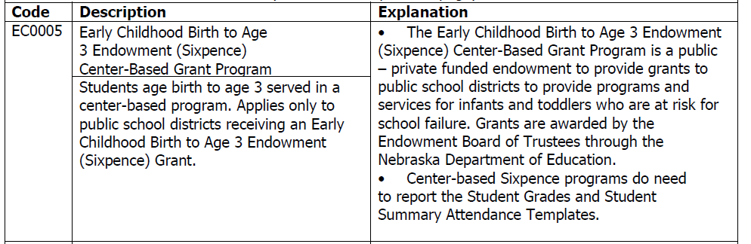
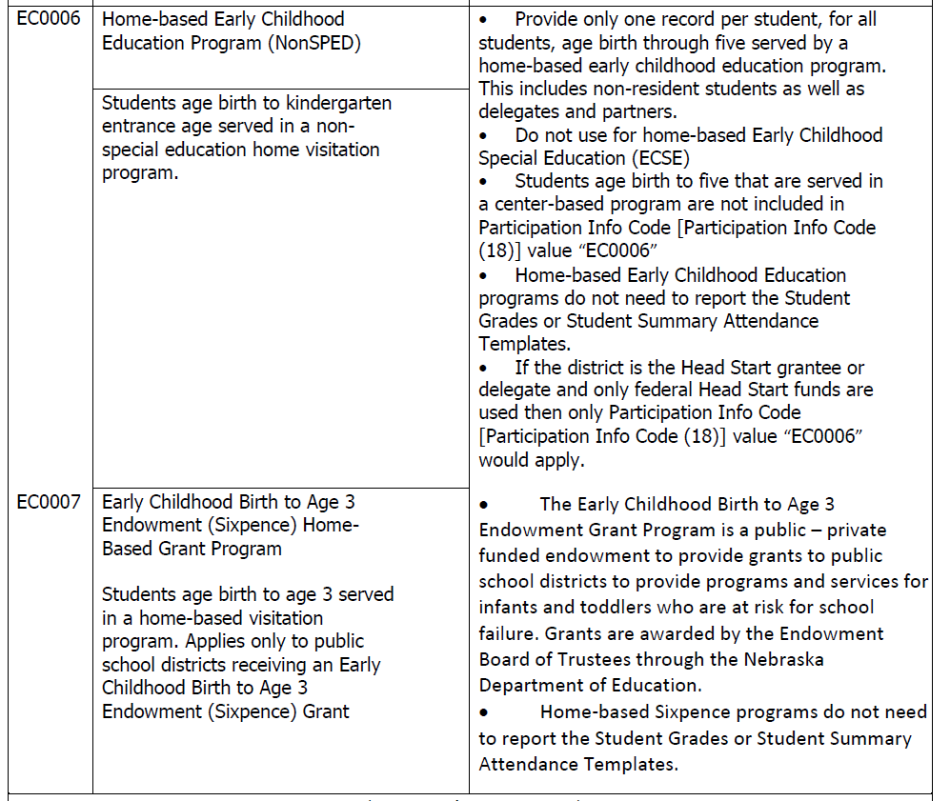

Staff Qualifications

Each home-based program’s Home Visiting Specialists must meet one of the below qualifications:
Home Visiting Specialist: Minimum of Bachelor’s Degree in:
- Early Childhood Education or Early Childhood Special Education,
- Nursing including at least twelve (12) graduate or undergraduate hours in any combination of family-centered practices or child and youth development,
- Child Development,
- Sociology or Psychology including at least twelve (12) graduate or undergraduate hours in any combination of family-centered practices or child and youth development,
- Social Work Including at least twelve (12) graduate or undergraduate hours in any combination of family-centered practices or child and youth development,
Training:
- Any staff that does not have coursework related to infants or toddlers must complete training on the Nebraska Early Learning Guidelines Birth to Five (42 contact hours by NDE approved trainer) or First Connections Online (45 clock hours) within three years of hire.
- Completion of all required training for program’s chosen curriculum, and GOLD.
- All staff must complete Home Visiting Core Practices and Principles On-line Training including; completion of all 7 on-line modules, activities workbook, and participation in the Sixpence study group within two years of employment.
- All staff must complete Nebraska’s Safe with You training, then other child abuse and neglect detection and reporting training annually.
Bilingual Home Visitor:
Programs may employ a Bilingual Home Visitor with an Associate’s degree, or the equivalency in credit hours. Sixpence staff must be provided with a detailed education plan, created in conjunction with a higher education institute. Such plan should indicate the timetable needed to enable the staff member to have Home Visiting Specialist qualifications within four years of hire.
See the Sixpence Grant Funds Use for Bilingual Family Engagement (home-based programs) Staff Tuition Reimbursement Policy for guidance.

NEBRASKA’S EARLY CHILDHOOD EDUCATION ENDOWMENT
Bilingual POLICY
TITLE: Grant Funds Use for Bilingual Family Engagement (home-based programs) Staff Tuition Reimbursements
POLICY: This policy reflects the Board of Trustees approval process for using Sixpence grant funds to reimburse the post-secondary tuition of Bilingual Home Visitors engaged in an education plan to meet the qualifications of a Home Visiting Specialist. This policy has been developed to address the shortage of qualified Bilingual Home Visitors, and is pursuant to the Family Engagement (home-based programs) Staff Qualification Quality Indicator for Bilingual Home Visitors. Under this indicator, “programs may employ a Bilingual Home Visitor with an Associate’s degree, or the equivalency in credit hours, with a detailed education plan, created in conjunction with a higher education institute, to meet the Home Visiting Specialist qualifications within four years of hire. The Bilingual Home Visitor must still be supervised by a Home Visiting Specialist.”
Guidelines:
In order to be reimbursable with Sixpence grant funds, tuition reimbursements made by school districts to Bilingual Home Visitors for post-secondary education need to be 1) reasonable and necessary, 2) allocable, and 3) legal. In order to establish “necessity,” a district needs to demonstrate that the tuition reimbursements will benefit the program, not just the Home Visitor, to a degree commensurate with the amount of the reimbursement. Only courses that result in a Bachelor’s degree in compliance with the requirements for a Home Visiting Specialist in Subsections 006.05A through 006.05A5 in Nebraska Department of Education Rule 11 (92 NAC 11) and in the Indicators for Staff Qualifications in the Sixpence Quality Criteria for Family Engagement Programs are appropriate for these funds.
In addition, the course program must include at least 12 credit hours specific to infants/toddlers and family engagement. Whenever possible, the First Connections Online training and Home Visiting Core Practices and Principle Online training should be taken for course credit. Additionally, all courses must be pre-approved by the district, and reimbursement shall be made upon successful completion of the course. Districts shall adopt or create policies/procedures/agreements with the Bilingual Home Visitor outlining expectations and limitations for minimum grades, attendance, course withdrawal or employment ending, use of work time for higher education purposes, and reimbursement procedures.
Bilingual Policy continued:
Documentation:
The district needs documentation in connection with the above factors to support its use of grant funds for this purpose. Such documentation shall include, at a minimum, the following:
1. Written justification of the necessity of employing a Bilingual Home Visitor in order to carry out the grant program;
2. Written explanation of the need to reimburse the Home Visitor’s tuition (in part or in whole) in order to carry out the grant program, after the Home Visitor’s documented attempts to utilize of all other sources of funds, such as Free Application for Federal Student Aid (FAFSA) and/or a Teacher Education Assistance for College and Higher Education (TEACH) Grant, if applicable.
3. Written documentation that the Bilingual Home Visitor was approved by the district in advance for tuition reimbursements, was employed in the District’s grant program for the duration of the course, and completed the course satisfactorily; and
4. Written documentation that the cost of the course was reasonable.
Total funds to be used for this purpose may not exceed $4,000 per Bilingual Home Visitor, per year, nor may exceed 5% of the total grant award. Grant funds may not be used for any other costs associated with post-secondary education, such as books, fees and travel.
EFFECTIVE DATE: March 9, 2016
Sixpence Early Learning Fund Attachment B, Quality Criteria for Family Engagement Programs, July 2015.

Intensity and Duration of Services
- Contact with each actively enrolled family at least three times per month for a total of at least 180 minutes per month.
- At least two of the three contacts must be individual personal visits in the home totaling 120 minutes. The intention of the Sixpence grant is for families to receive 3 in HOME visits per month. Parent child groups should only be used in place of a visit on a rare occasion when attendance is an issue.
If third contact is a group event, documentation should reflect attendance and parent-child-home visitor interaction. Program is designed to serve children for a minimum of 18 months.

Attendance Policy & The 85% Rule
All programs are required to maintain an enrollment and attendance record at a minimum 85%. Programs are expected to track attendance. Attendance reports must be made available for Sixpence Administration during the CQI visit.

Programs are to have an Attendance Policy. School Districts are given the flexibility to create their own Attendance Policy. Your Attendance Policy and report should be in each program’s Evidence Binder.

In an event a program does not have enrollment of at least 85% for two consecutive months, such program may be asked to provide monthly recruitment documentation.
UMNC database will be used verify discrepancies and noncompliance.

Transition Policy
To ensure the most appropriate placement and services following participation in a Sixpence program, transition planning must be made for each child and family at least six months prior to the child’s third birthday. The process must take into account; the child’s health status and developmental level, progress made by the child and family while in a Sixpence program, current and changing family circumstances, and the availability of Head Start, district preschool and other early childhood services in the community. As appropriate, a child may remain in a Sixpence program, following their third birthday, until he or she is eligible to transition into another program. Sixpence programs may not enroll children who are age three but rather continue to serve children through age three that are already enrolled in the program.

Programs shall have a written transition policy in place describing the process and timeline for transitioning children.
Programs need to maintain records of all their Sixpence children for a minimum of three years after exit.

TA Tidbit: If a child is enrolled in a Sixpence program at the time of their third birthday and there is no availability for them to transition into a preschool program, the child may remain in the Sixpence program until the following fall. At no time is a four-year-old allowed to be enrolled in a Sixpence Program.

Transition Policy for Children Age Three

Policy – This policy reflects the Board of Trustees expectation for transitioning of three-year olds.

The Board of Trustees believes that children who are at risk of failing in school should have continuity of service provision to respect and protect the child’s emerging sense of trust and to ensure there is not a gap in service provision from birth to three programs to kindergarten age.

To ensure the most appropriate placement and services following participation in a Sixpence program, transition planning must be made for each child and family at least six months prior to the child’s third birthday. The process must take into account; the child’s health status and developmental level, progress made by the child and family while in a Sixpence program, current and changing family circumstances, and the availability of Head Start, district preschool and other early childhood services in the community. As appropriate, a child may remain in a Sixpence program, following their third birthday, until he or she is eligible to transition into another program. Sixpence programs may not enroll children who are age three but rather continue to serve children through age three that are already enrolled in the program.

Programs shall have a written transition policy in place describing the process and timeline for transitioning children.

EFFECTIVE DATE: January 11, 2012

Supervision

- Program Supervisor has specific training in reflective supervision, infant-toddler development, program management, and in the specific program model/curriculum.
- Home Visiting staff receive individual or group supervision at least weekly, and this includes education, coaching and an opportunity to reflect upon practice and problem solve around client’s needs.
- Program Supervisor accompanies, and provides feedback, to Home Visiting staff on a minimum of: Three personal visits every six months (if full-time) during their first year; two personal visits every six months (if part-time) during their first year; three personal visits per year thereafter, (HOVRS video can be used in lieu of one physical visit.)
- The ratio of supervisors is 1:6, or sufficient enough to provide on-going individual support.
- Program must offer services on a year-round basis.

Administration

- All partner programs/providers are expected to maintain records providing evidence of sound, professional financial practices.
- Program must have an attendance policy that reflects an attendance rate of 85%.
- Enrollment should not fall below 85% of full enrollment, filling vacancies within 30 days.
- Program must maintain a process for ensuring that children most at risk are enrolled.
- Program must maintain a system of documentation that reflects program practice and child and family progress.
- Program must have a transition planning policy reflective of the Sixpence Transition Policy.

TA Tidbit Questions
How does Sixpence get my program’s attendance?
At the first of every month UNMC sends Sixpence Administration an attendance report listing children and prenatal mothers served. It is very important to have your database current and up to date.

If I enter families right away and they leave, won’t it hurt my program’s overall attendance rate?
If a family starts your program please put them into the database right away. Unfortunately, we all know a few families leave programs within the first month. If you exit families and children within 30 days of entry, they will not be counted towards your yearly retention rate.

How will this help with the evaluation process?
Some evaluation data is only taken into consideration if a child has been receiving Sixpence services for six months or more. Every spring and fall UNMC staff put together packets for programs. This process is time consuming for our evaluators. Keeping the data base current is beneficial in ensuring programs receive the right evaluations they need for the children they serve.

Caseload

Home Visiting staff have limited caseloads so that they can spend adequate time with each family (at least 12, but no more than 15 children depending on program model and community/family characteristics).

Curriculum
Program uses research-based, written curriculum designed to work with families, and congruent with Nebraska’s Early Learning Guidelines for Birth-Three Year Old’s.
Curriculum includes a personal visit plan and follow-up documentation.
Program approach is flexible and focused on families’ needs to the benefit of the child’s development.

Developmental Screening and Assessment

- Screen children for developmental delays within 45 days of program entry, and at least every six months thereafter, using a research-based screening tool.

- Refer all children identified through screening, assessment, or parent and/or staff concern for further assessment to the Early Development Network.

- Program must complete ongoing observation-based assessments of children’s development as required by Results Matter and UNMC-MMI; use results in development of individualized learning plans for children.

Partnerships

Community Partnerships
Sixpence grants require community partners to come together to develop and/or expand quality early childhood programs and services to best meet the needs of the community's most at risk children.
A Statement of Commitment/Partnership from each partner is required, and must be renewed and uploaded annually. This statement should list critical elements of all partners’ participation such as resources, time commitment, and ongoing representation that they (including the applicant school district) are committing to the partnership. A Statement of Commitment/Partnership form can be found on our Sixpence site at singasongofsixpence.org under the Resources tab.

Local Early Childhood Advisory Committee
Every Sixpence Program is required to have a local early childhood advisory committee that includes early childhood professionals, families, and community agencies. If there is an Early Head Start/Head Start Program that serves the community, that program must be given the opportunity to be represented on the local early childhood advisory committee. Additional representation might include the following: existing early childhood care and education providers, preschools, Head Start programs, providers of early intervention and early childhood special education services, Planning Region Teams, Early Learning Coordinators, resource and referral agencies, parents, and health and social service personnel. All members of the Advisory Committee must submit a Statement of Commitment/Partnership form. All Statement of Commitment/Partnership forms are to be renewed and uploaded annually. As a reminder Rule 11 requires these meetings adhere to the rules and regulations of the Open Meetings Act.

Family Partnerships
- Active parental participation on the Advisory Committee.
- Program must offer parent’s opportunities to develop and implement individualized family partnership agreements that describe family goals, responsibilities, timetables and strategies for achieving these goals as well as progress towards achieving them.
- Program must have a Family Partnership Agreement, which builds upon information obtained from the family and other community agencies concerning preexisting family plans. Provider must coordinate, to the extent possible, with families and other agencies to support the accomplishment of goals in any educational/service plans; i.e., IFSP.
- Program provides written information about philosophy, policies and procedures which shall encourage family engagement.
- Offer ongoing opportunities for parent involvement and at least monthly parent education opportunities that include, but aren’t exclusive to; car seat safety, safe infant sleep practices, child medical needs, prenatal care, abstinence from smoking, alcohol, and drugs while pregnant, breastfeeding, brain development, nutrition, physical activity/outdoor play, child and parental mental health/stress, and trauma/toxic stress. Such education topics can be provided as a group or individually. If families can’t attend the group, information is shared individually.

TA Tidbit: A good question for programs to ask themselves is, “what agencies and services do my families use and need the most?” Examples of potential partners are food pantries, shelters, community rec centers, crisis pregnancy centers, Head Start, community childcare providers, health departments, WIC, churches, schools and Child Protective Services.

Evaluation

If the program uses an approach for which national certification or accreditation is available, the program must obtain such certification or accreditation and maintain good standing.
- Any program partner must be in good standing with their licensing, regulatory or monitoring agency.

Program must participate in evaluation protocol as required by Results Matter; Results Matters Department of ED and UNMC-MMI; UNMC Data Base Results to be used in development of program improvement plans.

UNMC Data Collection
Prenatal Health Indicators Survey-Birth/Intake
Protective Factors Survey (FRIENDS)-Intake and each spring
Parent Satisfaction Survey- Completed each spring
PPVT-At age 3, completed year round based on birthday of the child
ITERS/Infant CLASS/Toddler CLASS-Completed in the fall by center based programs ONLY
HOVRS- (parent engagement only)-Completed in the winter
DAYC2-Fall (if not completed pervious spring) and EACH spring for English primary language children that are 8 months or older.
MacArthur Level I- Fall (if not completed pervious spring) and EACH spring for English primary language children that are 8 months to 18 months
MacArthur Level II- Fall (if not completed pervious spring) and EACH spring for English primary language children that are 19 months to 30 months
DECA- Fall (if not completed pervious spring) and each spring
KIPS- Fall (if not completed pervious spring) and each spring by home based programs and select center based programs
Data Collection continued
Every Fall and Spring programs will receive packets of evaluation tools to be filled out for each family. These packets will be paper clipped together with each individual child’s name on them. Programs then have six weeks to fill out the tools and send them back to Munroe Meyer Institute in the self-addressed envelope. UNMC Evaluation Guidebook can be found on Sixpence website under the Resources tab.
Each home visitor is required to submit a 30-minute video for HOVRS evaluation. UMNC collects these videos in the winter of each year. Programs will be contacted by UMNC staff concerning timetables.

Results Matter GOLD
Programs are required to adhere to the GOLD requirements of the Nebraska State Education Department's Results Matter Guidebook.
Effective July 2016, Sixpence HOME BASED programs will be required to complete only the Fall and Spring checkpoints. However, all Sixpence programs will adhere to partnership guidelines.

GOLD -When enrolling new children into Gold, under funding source click a Nebraska Early Childhood Endowment Program. Enter children as you enroll them at the Teaching Strategies website: https://gold.teachingstrategies.com/gold/teachers/mc.cfm ; see Results Matters guidebook for further clarification.

Frequently Asked Questions
At what age does the assessment begin?
- The initial assessment begins when the child is 6 months old.
I had a child enroll three weeks before the check point is due. Do I have to finalize a checkpoint for them?
- Check points are only mandatory for children enrolled at least 45 days before the due date of the upcoming check.
What if a child is born prematurely has a significant illness, or lengthy absences?
- Do not adjust the child’s age for prematurity.
- For any child birth to age five, the assessment can be postponed if the child has a significant illness or hospitalization during the 45-day assessment period, and as a result cannot have a valid observational assessment completed.
- If a child is absent for 30 days or more for any reason, archive the child’s data and start over when/if the child returns.

Who is required to complete GOLD Inter-Rater Reliability (IRR) Certification?
- IRR Certification is required to be completed online by each teacher/practitioner responsible for rating child observations and documentation in GOLD for children birth to age five.
- One year of GOLD experience is necessary prior to taking the IRR.
- NDE requires that Individual Inter-Rater Reliability (IRR) be completed by December 31 of each year. However, a district may establish an earlier completion date.
- GOLD online administrators and program supervisors must plan for and assure that teachers/practitioners who score child documentation in GOLD have ample time to complete.
- There is no cost for the IRR. It is provided as part of each district or Head Start GOLD subscription.

Which age groups in the IRR must be completed?
In Nebraska, most teachers/practitioners work with children birth to kindergarten entrance age. For these individuals, two age groups are required for certification:
Birth through age 2, including children with disabilities.
Preschool (3 to 5), including children with disabilities.
- If a teacher/practitioner works only with children B through 2, or only Preschoolers, then only one age group is required for certification.
- Each age group selected must include children with disabilities, regardless of whether a teacher is currently serving a child with a disability.

How much time do teachers need to complete the IRR?
- It takes an average of about 3 hours to complete one age group. For teachers/providers who work across two age groups (Birth to 2 and 3 to 5), 6 hours should be allowed for completion. The IRR does not need to be completed at one time.
- There are no time limits when taking the IRR. As much time as needed may be taken.
- A score of at least 80 percent is required in order to attain certification. If a score in a particular area of development/learning is less than 80% (i.e. social-emotional), then only that area is required to be retaken, not the entire IRR. If an area needs to be re-taken, a new child portfolio on a different child will be scored.

What are the GOLD checkpoint requirements for children birth to kindergarten entrance age?
Only Fall and Spring checkpoint periods are required. Any entry or exit data received during the Winter checkpoint must be entered and finalized.
For children ages 3 to 5:
- Preschoolers regardless of program or service location (with and without IEPs);
- Two GOLD Checkpoints required: Fall and Spring each year.
- Preschoolers enrolled in Head Start Programs or in programs with Head Start partnerships, regardless of location, much follow Head Start Performance Standards (with and without IEPs).
For infants and toddlers Birth to age 3:
- Infants and toddlers enrolled in both home AND center-based programs, or center-based programs, only (with and without IFSPs):
  - Two GOLD checkpoints are required: Fall and Spring each year.
- Infants and toddlers in home-based programs only (with IFSP):
  - Two Gold checkpoints required: at Part C entry and Part C exit.
- Infants and toddlers with services coordination only much be entered at entry and exit checkpoints.
- Infants and toddlers in home-based programs only (without IFSPs):
- Two GOLD checkpoints required: Fall and spring each year.
- Infants and toddlers enrolled in Early and Start programs or in programs with Early Head Start partnerships, regardless of location, much follow Head Start Performance Standards (with and without IFSPs)
- Infants and toddlers enrolled in a Sixpence Child Care Partnership, regardless of location, must follow Sixpence Quality Criteria (with and without IFSPs).
What are the checkpoint periods in GOLD?
- FALL: August 1- October 31
- WINTER: November 1-February 15
- SPRING: February 16 – May 31
- SUMMER: June 1 – July 31 {12-month programs only}
Which GOLD assessments items must be completed?
- For all children birth to kindergarten entrance age served by school districts, GOLD progressions must be documented online and finalized for Objective 1 through 23. Objectives 1-23 include dimensions and progressions in six areas of development and learning:
  - Social-Emotional; Physical; Language; Cognitive; Literacy and Math
  - The two English Language Acquisition objectives must also be completed for a child age 3 and older if indicated by the results of the GOLD Home Language Survey

Objectives 24-36 are not required to be assessed by school districts, are required for Head Start programs. These objectives are in the areas of Science and Technology; Social Studies and The Arts.

Networking Events & Site Visits
- Fall Networking: In the fall, Sixpence hosts a mandatory Data Camp. At this event, programs will have the opportunity to examine and disseminate their annual data snapshots with UNMC and Sixpence Administration.

- Spring Continuous Quality Improvement (CQI): In February/March/April, Sixpence Administration will visit each individual program to ensure the Sixpence Quality Criteria are being met. As the grantee, a district representative MUST attend these meetings, even if a partner is providing the service.

- Programs can request a site visit or request a ZOOM conference call at any time.

Sixpence Website

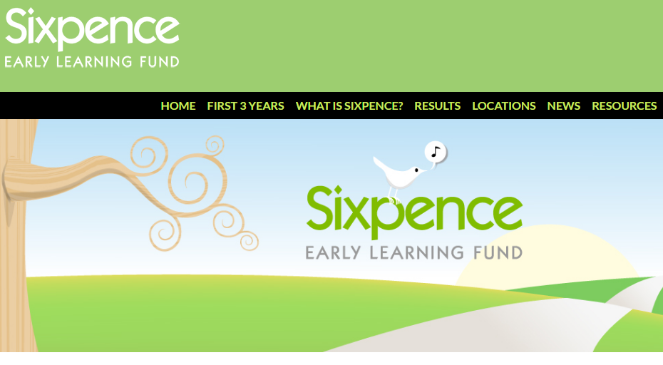
The Sixpence Website can be found at www.singasongofsixpence.org

Every school district has a private portal on the Sixpence Website.

The portal login can be found under the Resources TAB. The private portal has the District’s Sixpence antiquated documents. Now, much of the information that was uploaded to the portal in previous years is now uploaded into the GMS system. Currently the only documents that need to be uploaded to the private portal is the End of Year Match Report due August 15th.

Each District is assigned a single username and password for the portal. It is Sixpence Policy to only release login information to the program supervisor. Ongoing information will be sent (via email) to the person listed as the contact person on the grant application and/or identified as the primary contact for Sixpence. Please let Sixpence Administration know if the District contact changes.

Also found under the resources tab there is a wealth of information which the public has access to. Examples are listed below.

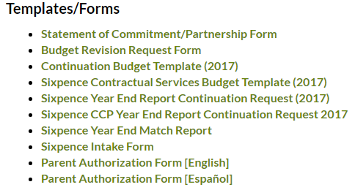
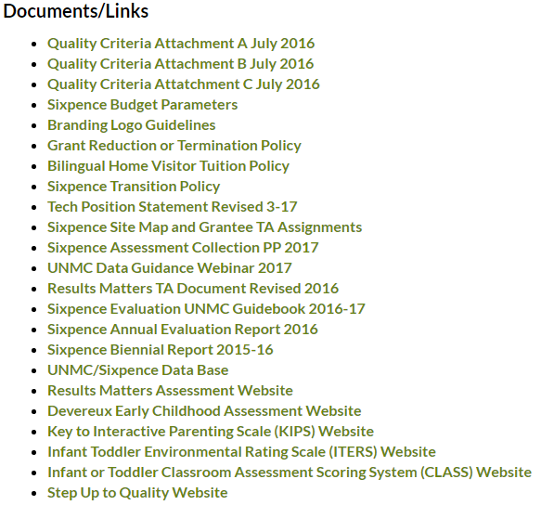

Technology Use Position Statement
This statement is intended primarily to provide guidance to those working with Sixpence programs, serving children from birth through age 3.

Infants and toddlers are growing up in environments saturated with a variety of traditional and new technologies at a time of critical brain development, building secure relationships and establishing healthy behaviors. Technology and interactive media are tools that can promote effective learning and development when they are used intentionally, within the framework of developmentally appropriate practice, to support learning goals established for individual children. Technology and media should not exclude, diminish or interfere with children’s healthy communication, social interactions, play and other developmentally appropriate activities with peers, family members and educators/caregivers. Note: “educators/caregivers” is the term used in this statement to capture the role of any adult working with any child in any capacity/environment.

In aligning with the latest American Academy of Pediatrics recommendations, Sixpence offers the following principles to guide the use of technology and interactive media:
Using Developmentally Appropriate Practices to Guide Technology Use
A mindful approach should be used when selecting and using technology as it enables healthy development, learning, creativity, interactions with others and relationships. The use of technology should align with curriculum goals, a child-centered and play-oriented approach, hands-on exploration, and relationship building.
Technology and media should not replace activities such as creative play, real-life exploration, physical activity, outdoor experiences, conversations and social interactions that are important for children’s development. Technology and media should be used to support learning, and to expand young children’s access to new content, not as an isolated activity, or as the only exposure/experience with the content.

Using Technology Appropriately
Technology should be used in moderation, and to enhance educational experiences, not to replace essential activities, experiences and materials.
Sixpence joins the public health community in discouraging the use of screen media for children under the age of 2. For children younger than 2 years, evidence for benefits of media is still limited. For children 2-5 years of age, screen time should be limited to 1 hour per day of high quality programming.
Using Technology Effectively
Effective uses of technology are active, hands-on, engaging and empowering. They give the child control, provide adaptive scaffolds to ease the accomplishment of tasks, and are used as one of many options to support children’s learning.
Fostering Positive Interactions While Using Technology
Effective technology tools connect media and activities with an emphasis on co-viewing and co-participation with educators/caregivers to help children understand what they are seeing and to help them apply what they learn to the world around them. Because of their immature symbolic cognition, memory, and attention skills, infants and toddlers cannot learn from traditional digital media as they do from interactions with educators/caregivers. Infants and toddlers have difficulty transferring that knowledge to their 3-dimensional experience. The chief factor that facilitates toddlers’ learning from commercial media (starting around 15 months of age) is the role of the educators/caregivers watching with them and re-teaching the content.

Using the Sixpence Logo
At Sixpence, we believe that using our logo plays an important part in Nebraska's continued investment in the healthy development of our youngest children. Using your Sixpence logo is also a key strategy for building public support for new and ongoing investments that keep programs like yours strong and thriving.
Logo Use Guidelines:
- Sixpence Logos may not be altered in size, color or format.
- All flyers, pamphlets, signage, wearable or carry-able gear must have the approved Sixpence logo, in addition to Grantee’s local community identifier, and partner logos (if applicable.)
- Grantees shall develop or adhere to their local entity’s policy on appropriate usage/wearing of logos. It would not be appropriate to wearing or carrying logos while exhibiting, or perceived to be participating in, behaviors/actions not in line with the values of the partnering organizations. Examples: wearing a logo t-shirt to a bar, participating in a political event carrying a logo tote.
- Sixpence logos can be found on Grantee's private website under Marketing Materials.
- Grantees and partners are encouraged to consult with their TA Specialist prior to ordering signage or gear using the Sixpence logos.

Marketing/Branding
As a Sixpence grantee or partner, it's important to know how best to promote your program, within the Sixpence umbrella while honoring your individual uniqueness. These Branding and Logo Use Guidelines exist to recognize that your program is aligned with the high-quality standards set forth by Sixpence, but wouldn’t be possible without your school district and community partnerships.

Branding Guidelines:
- All school district home based and center based programs should incorporate “Sixpence” and their local community into their name. Child Care Partnership grantees should consider naming their program in such a way that it differentiates itself from these existing programs.
- Childcare providers participating in the Childcare Partnership grant may indicate they are working in partnership with a Sixpence funded program, while continuing to use their established licensed name, but should not use Sixpence in their name.
- Programs are encouraged to recognize their school district and local community partner (if applicable.) Examples: “Falls City Sixpence,” “York Public Schools’ Family Foundations, a Sixpence program,” Ord Sixpence, a partnership between Ord Public Schools and Central Nebraska Community Action Program.”
Programs have access to the Approved Sixpence logos and other resources under the Resources tab on www.singasongofsixpence.org.

Branding and Logo Use Guidelines
Adopted by the Board of Trustees 11/11/16

As a Sixpence grantee or partner, it's important to know how best to promote your program, within the Sixpence umbrella while honoring your individual uniqueness. These Branding and Logo Use Guidelines exist to recognize that your program is aligned with the high quality standards set forth by Sixpence, but wouldn’t be possible without your school district and community partnerships.
Branding Guidelines:
- All school district home based and center based programs should incorporate “Sixpence” and their local community into their name. Child Care Partnership grantees should consider naming their program in such a way that it differentiates itself from these existing programs.
- Childcare providers participating in the Childcare Partnership grant may indicate they are working in partnership with a Sixpence funded program, while continuing to use their established licensed name, but should not use Sixpence in their name.
- Programs are encouraged to recognize their school district and local community partner (if applicable.) Examples: “Falls City Sixpence,” “York Public Schools’ Family Foundations, a Sixpence program,” Ord Sixpence, a partnership between Ord Public Schools and Central Nebraska Community Action Program.”

At Sixpence, we believe that using our logo plays an important part in Nebraska's continued investment in the healthy development of our youngest children. Using your Sixpence logo is also a key strategy for building public support for new and ongoing investments that keep programs like yours strong and thriving.
Logo Use Guidelines:
- Sixpence Logos may not be altered in size, color or format.
- All flyers, pamphlets, signage, wearable or carry-able gear must have the approved Sixpence logo, in addition to Grantee’s local community identifier, and partner logos (if applicable.)
- Grantees shall develop or adhere to their local entity’s policy on appropriate usage/wearing of logos. It would not be appropriate to wearing or carrying logos while exhibiting, or perceived to be participating in, behaviors/actions not in line with the values of the partnering organizations. Examples: wearing a logo t-shirt to a bar, participating in a political event carrying a logo tote.
- Sixpence logos can be found on Grantee's private website under Marketing Materials.
- Grantees and partners are encouraged to consult with their Administrative Education Specialist prior to ordering signage or gear using the Sixpence logos.

Finances

GMS and End of Year Reports

Early Childhood Endowment Grant Continuation Application – due by May 1, 2017
The Early Childhood Endowment grant is online in GMS https://nde.mtwgms.org/NDEGMSWebv02/logon.aspx The application must be complete and submitted by the due date. Failure to submit by the due date may result in forfeiture of grant funding. The amount of your grant allocation appears in GMS on the Allocations page. This application for continuation should reflect activities from the current grant year, and include your budget (per approved allocation) and any requests for changes for the upcoming grant year.
A template of the required GMS fields is attached to assist you and/or your partners in reporting, but all information must be submitted via GMS.

GMS Instructions:
The school district, as the Sixpence grantee is responsible for uploading the Continuation Application(s) and Budget(s) for the Sixpence center and home-based (family engagement) grants.

- After logging in select “GMS Access / Select” from the menu List, select “FY 2018” from the drop down list and click “Create” associated with the “Early Childhood Endowment Grant.”

- Be sure to complete each section/tab, as an error will not allow you to submit your application.

- Watch for “instructions” link on the upper right corner for additional guidance. This is especially helpful in the budget section, and includes the “Sixpence Grant Parameters.”

- Within GMS, there is often the option to select “upload” for many of the required fields. Feel free to use this feature, as long as the upload contains the same information that the field requests. Some things that MUST be uploaded are all Partnership Agreements/MOUs/LOAs, etc. and Budget.

Year-End Match Report – due August 15, 2017
You are required to submit the Year End Match Report for the prior program year. This form provides documentation of the required match to the grant. This form is attached and should be uploaded into your portal on www.singaongofsixpence.org prior to the final grant disbursement, no later than August 31 of the program year.

Final Claim for Grant Funds – due August 31
Grant funds must be obligated by June 30, liquidated within 45 days, and reimbursement requested within 60 days. Practically this means you can order goods, but not services, on or before June 30 so long as they will be received and paid for by August 14 and reimbursement requested by August 31. Services must be performed by June 30 to be considered obligated. No services performed after June 30 will be eligible for reimbursement by the 2016-17 grant. You may obligate personnel costs if employee is under a contract that extends beyond June 30. Any work performed after June 30 is considered outside of the grant term. Any personnel costs paid in July for work performed on or before June 30 would be considered an obligation of the current grant period, i.e. a 9/12 teacher’s contract. If you have questions regarding expenses reimbursement, please contact Shane Rhian at (402) 471-4313 or shane.rhian@nebraska.gov

Disbursement of Grant Funds-
School Districts may request grant funds on a reimbursement basis only. Documentation of expenditures must accompany each request. Request must match your approved budget. To facilitate this requirement, as well as to assist with tracking your grant costs and remaining funds, please also submit the Sixpence Budget Allocation Form (Contractual Services Budgets ONLY), indicating the line item which the expenses are allocated. This form is available on your private site under the Resource Library tab. This does not replace Form NDE 28-003 (to be used to request funds) which is available online at www.nde.state.ne.us/ADSS/NDE28003.pdf.

Amendments
Amendments to an approved application and budget are required when:
- The scope of the program is expected to change, either to remove or add a major component of your approved grant model; or
- Grantees wish to revise amounts across budget codes/categories, exceeding 25%, or $2,500, whichever is greater. To reduce the number of amendments, the grantee has discretion to over-or under-spend a budget code/category by 25%; or

Indirect Cost and Restrictions
Operating funds may not be used for any indirect costs which exceed the district’s established rates. Sixpence funds may not be used for capital improvements, and/or purchase of buildings, land, or vehicles.

Expending Grant Funds-
Grant funds must be obligated by June 30, 2016, liquidated within 45 days, and reimbursement requested within 60 days. Practically this means you can order goods, but not services, on or before June 30 so long as they will be received and paid for by August 14 and reimbursement requested by August 29. Services must be performed by June 30 to be reimbursed.

Termination Policy
NEBRASKA’S EARLY CHILDHOOD EDUCATION ENDOWMENT
POLICY
TITLE: Grant Funding Reduction/Termination Policy

POLICY: This policy reflects the Board of Trustees role in reducing the funding or terminating a Sixpence grant.

Termination of Early Childhood Education Endowment (Sixpence) grants by grant recipients or reduction or termination of grants by the Early Childhood Education Endowment (Sixpence) Board of Trustees, hereunto referred to as The Board, before the completion of the grant period requires written notice to the other party of the grant, and the return of unexpended and unencumbered funds effective on the date of the receipt of the termination notice.

The authorized applicant representative, as designated by the grant recipient on the initial application or as amended in writing, may terminate a grant at any time. Such a termination request must be in writing and will become effective when received by the Board.

A grant may be reduced or terminated by the Board when it has been determined that the grant activities are outside the approved application, conditions of the grant award notification are not met, there is fraud or fiscal mismanagement, or there is lack of adequate funding. In the event the Board proposes to reduce or terminate the grant funding, it shall provide the authorized applicant representative of the grant recipient with written notice of the reasons for such action and an opportunity to be heard at the Board meeting at which the action is placed on the agenda. The Board may take final action to reduce or terminate the grant at that meeting, or at a subsequent meeting, and shall provide the authorized applicant representative of the grant recipient with written notice of the funding reduction or termination decision. Administrative authority for Early Childhood Education Endowment Grants for prekindergarten programs for children from birth to age three (3) (Sixpence Grants) resides with the Early Childhood Education Endowment Board of Trustees therefore, there is no appeal of any action by the Board to the State Board of Education. The decision of the Board to reduce or terminate a grant is the final administrative decision.

EFFECTIVE DATE:

________________________________ ________________
Chair Board of Trustees Date

