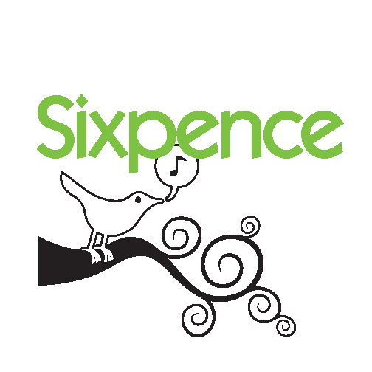Branding and Logo Use Guidelines
Adopted by the Board of Trustees 11/11/16

As a Sixpence grantee or partner, it's important to know how best to promote your program, within the Sixpence umbrella while honoring your individual uniqueness. These Branding and Logo Use Guidelines exist to recognize that your program is aligned with the high quality standards set forth by Sixpence, but wouldn’t be possible without your school district and community partnerships.
Branding Guidelines:
- All school district home based and center based programs should incorporate “Sixpence” and their local community into their name. Child Care Partnership grantees should consider naming their program in such a way that it differentiates itself from these existing programs.
- Childcare providers participating in the Childcare Partnership grant may indicate they are working in partnership with a Sixpence funded program, while continuing to use their established licensed name, but should not use Sixpence in their name.
- Programs are encouraged to recognize their school district and local community partner (if applicable.) Examples: “Falls City Sixpence,” “York Public Schools’ Family Foundations, a Sixpence program,” Ord Sixpence, a partnership between Ord Public Schools and Central Nebraska Community Action Program.”

At Sixpence, we believe that using our logo plays an important part in Nebraska's continued investment in the healthy development of our youngest children. Using your Sixpence logo is also a key strategy for building public support for new and ongoing investments that keep programs like yours strong and thriving.
Logo Use Guidelines:
- Sixpence Logos may not be altered in size, color or format.
- All flyers, pamphlets, signage, wearable or carry-able gear must have the approved Sixpence logo, in addition to Grantee’s local community identifier, and partner logos (if applicable.)
- Grantees shall develop or adhere to their local entity’s policy on appropriate usage/wearing of logos. It would not be appropriate to wearing or carrying logos while exhibiting, or perceived to be participating in, behaviors/actions not in line with the values of the partnering organizations. Examples: wearing a logo tshirt to a bar, participating in a political event carrying a logo tote.
- Sixpence logos can be found on Grantee's private website under Marketing Materials.
- Grantees and partners are encouraged to consult with their TA Specialist prior to ordering signage or gear using the Sixpence logos.

